**Quandl's Financial Data Analysis (MRF)**

Some **Insights** from MRF share visualizations from data (1991-2023)

Rise to New Heights:

The plotted data showcases how MRF shares steadily climbed over the years, surpassing various milestones. By carefully observing the graph, we can witness the gradual increase in share prices, culminating in a significant achievement of reaching the remarkable milestone of 1 lakh plus in 2023. This accomplishment highlights the immense growth potential and investor confidence in MRF.

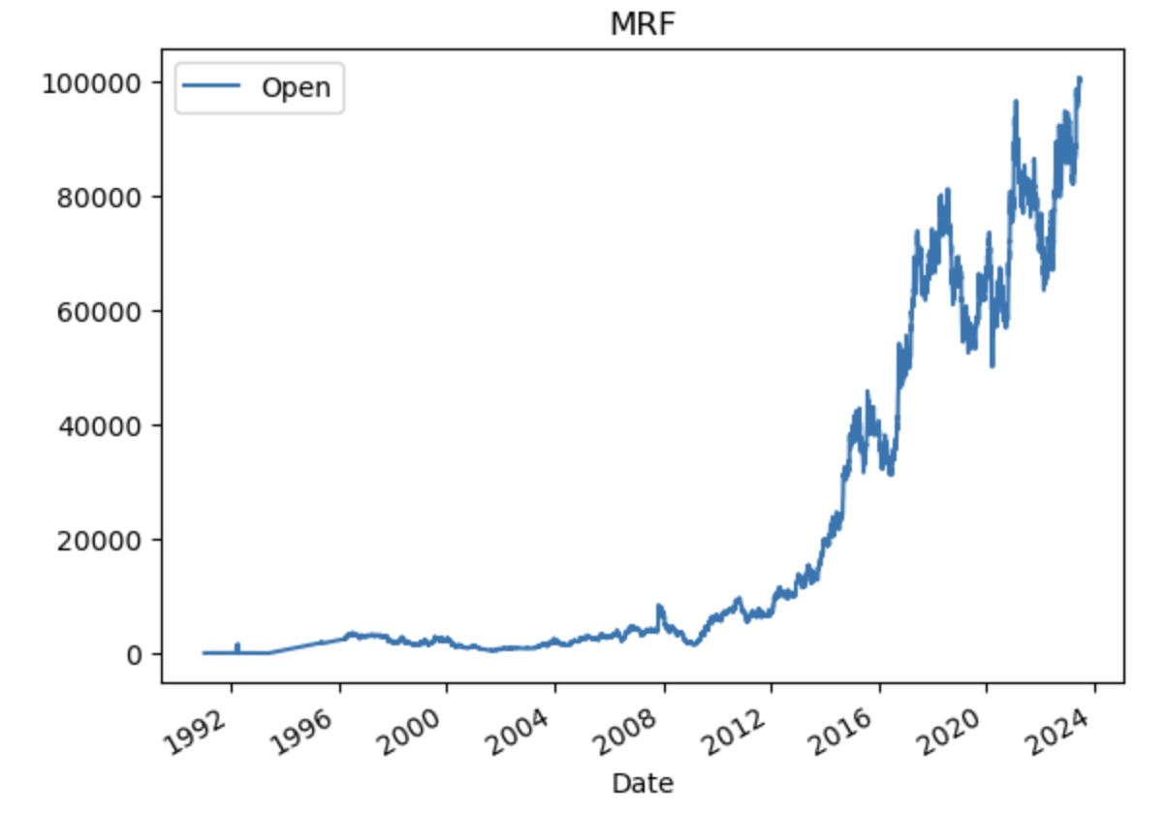

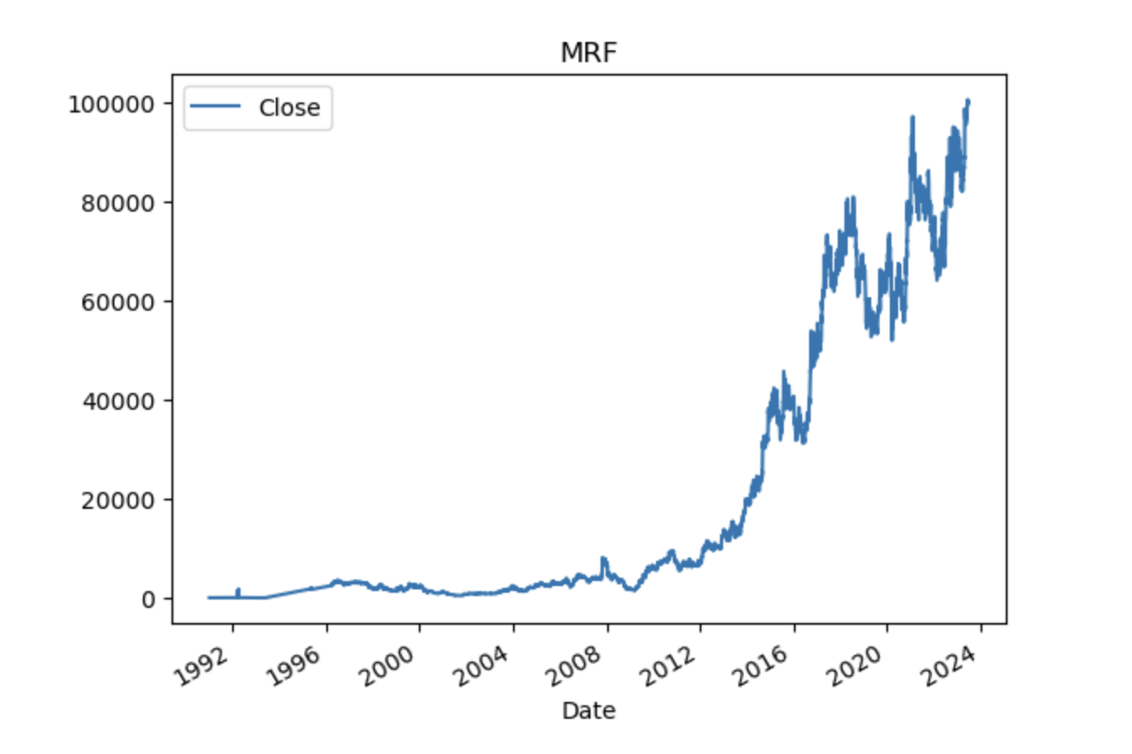

Fluctuations and Highest Deliverable Quantity:

From 2003 to 2012, there were significant fluctuations in the deliverable quantity of MRF shares. However, the highest recorded deliverable quantity during this period occurred in 2008, reaching approximately 40,000 shares. This indicates a considerable trading interest and liquidity during that specific time.

Market Activity and Trends:

The deliverable quantity data also reveals interesting trends between 2017 and 2024. During this period, the deliverable quantity of MRF shares remained below 10,000 shares, indicating a relatively lower trading activity compared to previous years. This trend suggests a potential shift in market dynamics, which could be influenced by various factors such as investor sentiment, industry developments, increased stock price, or broader market conditions.

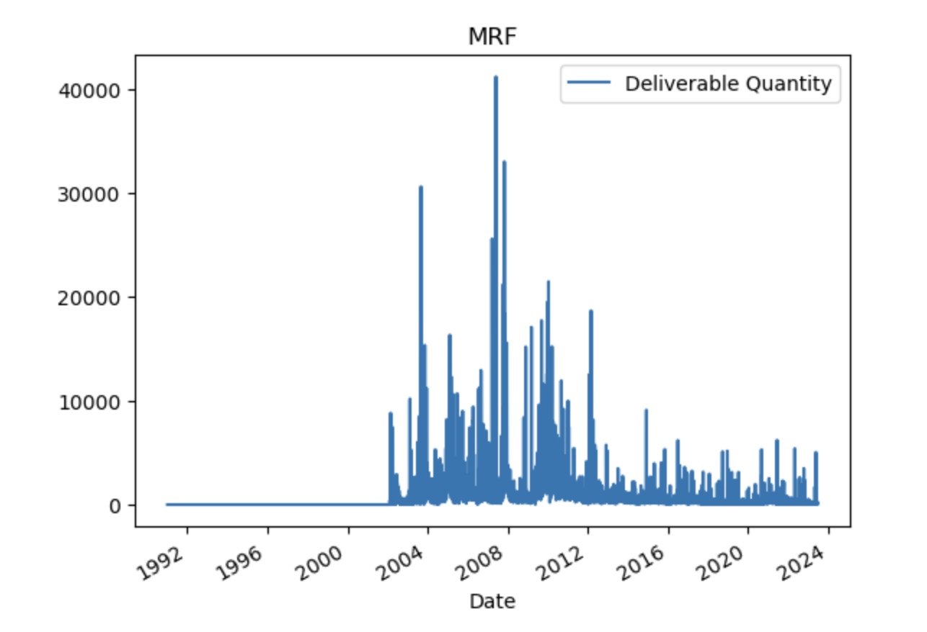

Sustained Growth :

During the period from 2012 to 2023, the moving averages (MA) for the stock exhibited a remarkable pattern of consistent growth. With relatively low volatility, the MA showed a persistent upward trend. Despite occasional minor fluctuations, the overall trajectory remained positive, indicating a steady and gradual increase in the stock's value over time.

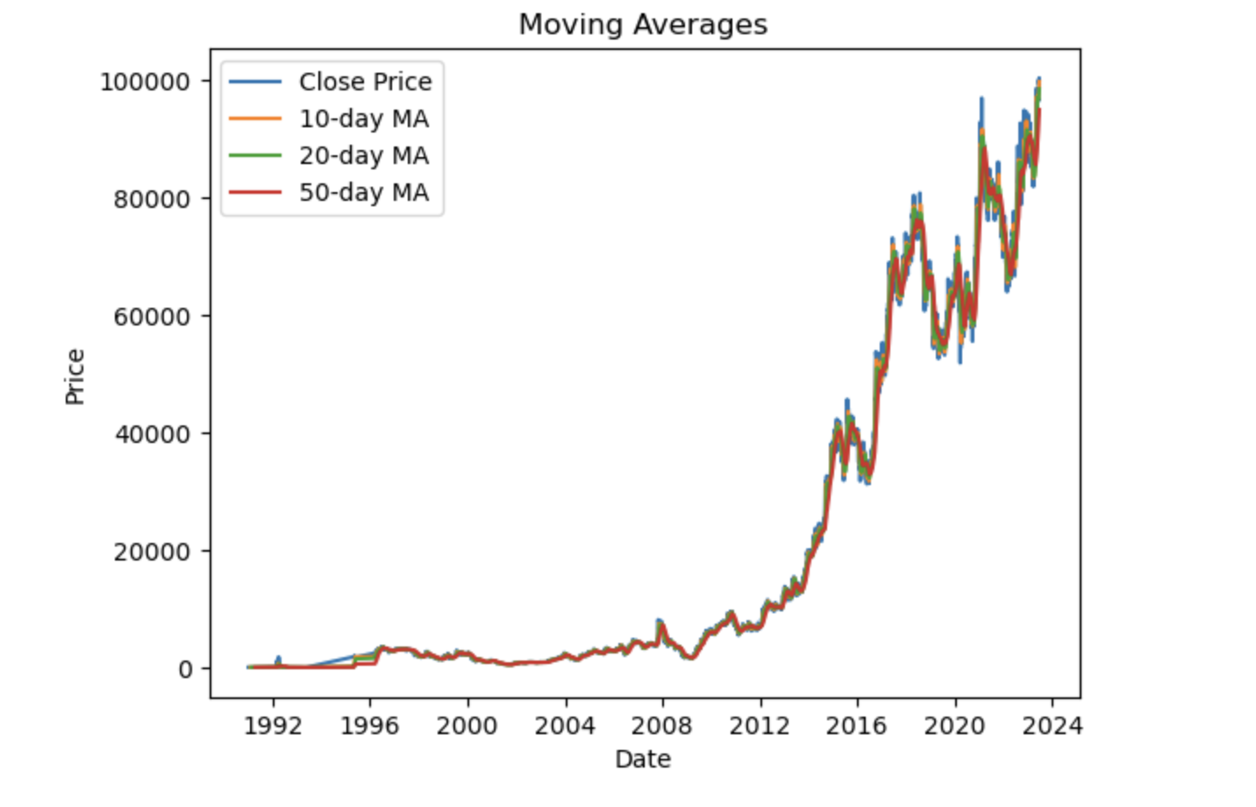

In dataset, "Spread H-L" refers to the difference between the highest and lowest prices of a particular security within a given time period. It represents the range or volatility of price movement during that period.

Peak Volatility (2020):

The highest level of price volatility was observed in 2020 when the Spread H-L metric reached approximately 10000. This signifies an exceptional level of price range and volatility, potentially driven by significant market events such as economic crises, geopolitical factors, or industry-specific developments. The stock experienced substantial price swings, posing challenges and opportunities for investors.

1991-2008: Period of stability with minimal Spread H-L, indicating limited price fluctuations.

2008-2015: Volatility increased, leading to a wider Spread H-L range.

2015-2020: Continuous expansion of price fluctuations and higher Spread H-L.

2020: Peak volatility observed with the highest Spread H-L level.

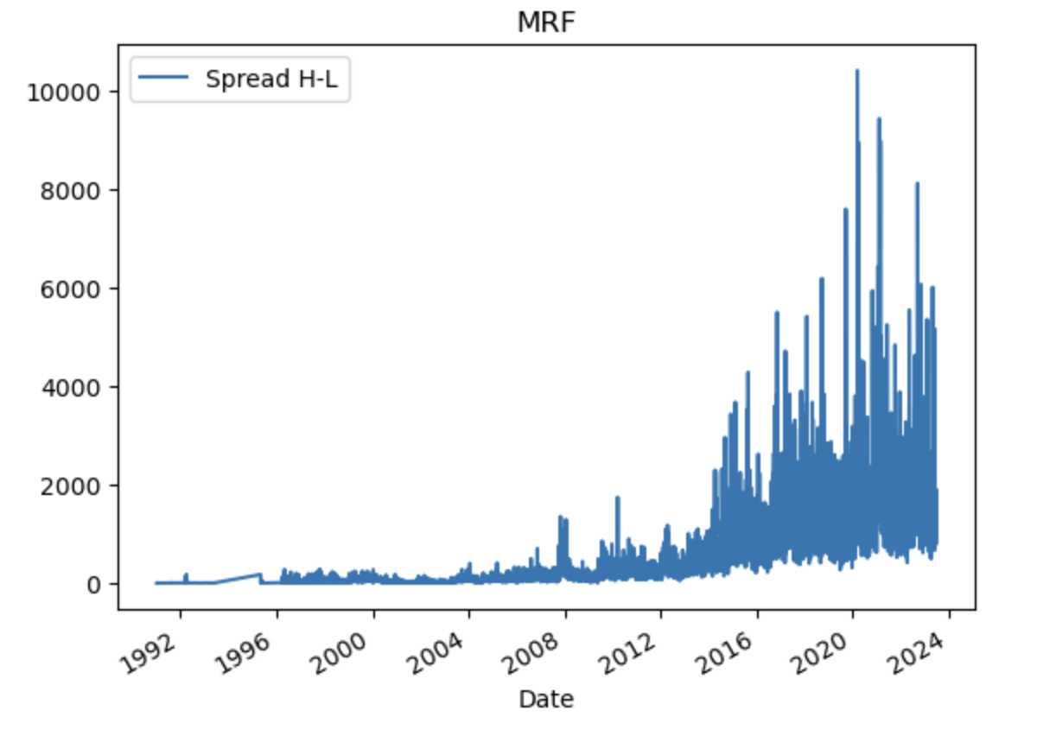

On the other hand, "Spread C-O" refers to the difference between the closing price and the opening price of a security within a specific time frame. It indicates the price movement from the opening of the period to its closing, providing insights into the intraday or interday price fluctuations.

Widening Difference Graph:

Over time, the below graph representing the Spread C-O difference became wider, illustrating the expanding range of price movements within a trading day. This widening difference graph is a clear indication of increased intraday price volatility and potential trading opportunities.

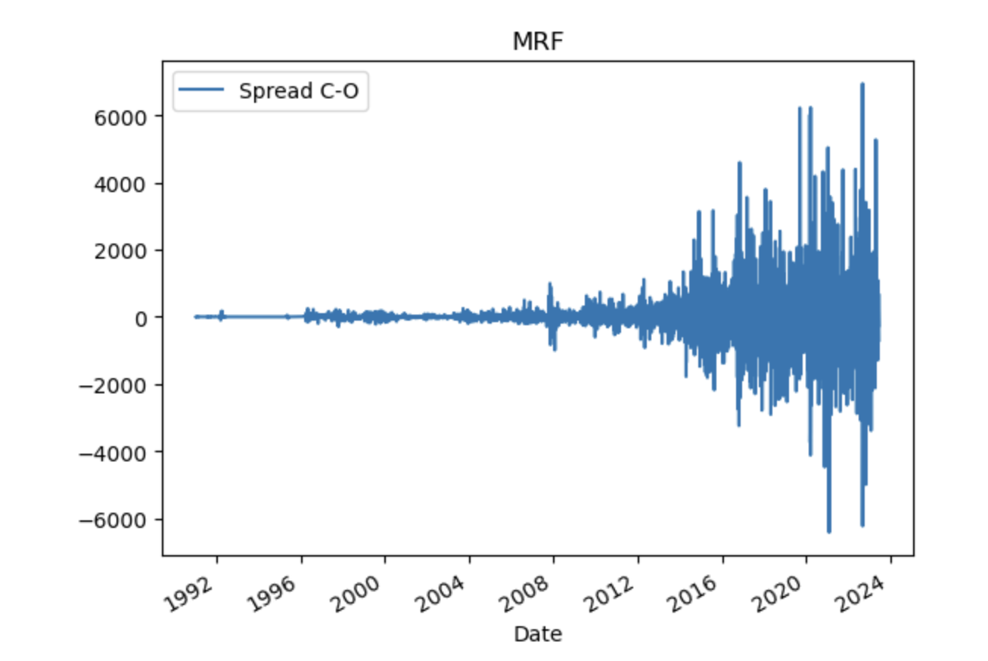

**PreProcessing Data**

Filling Null values

1.

The reason for filling the null values in the "Deliverable Quantity" column with 0 is that the deliverable quantity should typically be less than the number of shares traded. If some values were coming out to be large after filling with the mean, it suggests that the mean calculation might not accurately represent the actual values in the dataset.

By filling the null values with 0, we are assuming that there were no deliverable quantities for those particular instances. This approach is a conservative assumption and ensures that the deliverable quantity is not overestimated or distorted by using mean values. Since there are continuously null values in the dataset and using forward fill (ffill) is not possible, filling with 0 is a reasonable approach to handle missing values in this scenario.

2.

The "Percentage of Deliverable Quantity to Traded Quantity" (% Deli. Qty to Traded Qty) represents the proportion of shares that were actually delivered in relation to the total shares traded for a given time period. In this case, the null values in the % Deli. Qty to Traded Qty column can be filled with 0.

Filling the null values with 0 implies that there were no deliverable quantities in those instances, indicating that all the shares traded were not delivered. This assumption helps maintain consistency in the dataset and avoids overestimating the deliverable quantity percentage.

Since using mean or forward fill is not appropriate due to the continuous presence of null values, filling with 0 is a suitable choice. It ensures that the missing values are handled appropriately without introducing bias or distorting the actual proportion of deliverable quantities to traded quantities.

**RESAMPLING**

Resample the data to weekly frequency and selected the last value of each week as the closing price: